Dynamic Motion Design – Power BI



Submitted in part-fulfillment of the requirements for the award of
Bachelor of Science (Honours) in Computing with Digital Media
Institute of Technology Tralee

Name : Aaron Tan Jian Wen

Supervisor : Linda O Loughlin

Submission Date : 20 April 2021

Contents
1. Introduction 3
2. Objectives 3
3. Methodology 3
3.1 Data Collection 3

1. Introduction
Humans are born without prejudices. However, the environment that one grows up in can affect the way of thinking, including negative feelings towards another based on looks and appearance. Discrimination is not a modern phenomenon, throughout history there have been many cases of such practice being carried out across the world – such as slavery in America and the Indian caste system. Modern day prejudices involve many aspects – gender (misandry and misogyny), sexuality (homophobia), religion (Islamophobia), disability (ableism) and so forth. Acts of prejudice can be as common as to deny privileges or basic human rights, such as a bus seat or a job, to more radical acts, in which the victim could be hurt or even killed.

In the past few years, there have been many cases of such acts of terror being committed around the world. These include but not limited to Christchurch mosque shootings, Orlando night club shootings, Islamophobia after the events of 9/11 and the shooting of several women by Elliot Roger.

The reactions of the public to such events are very mixed. Victim blaming, downplaying the tragedy and deaths of those involved, and to some extent praising the perpetrator are all responses to hate crimes. On the other hand of the spectrum, movements like Black Lives Matter and Me Too strive to highlight the fact that certain people are treated differently for being who they are.

2. Objectives
- To highlight the hate crimes directed towards communities of certain gender, race, sexuality, and disability by certain demographics.
- To monitor and analyse the reactions from the community towards violent events where specific human characteristics have seemingly played a role – e.g., the arrest and murder of George Floyd and the shooting of 6 Asian women in Atlanta.

3. Methodology

3.1 Data Collection
This project will utilize pre-existing datasets such as those from Kaggle and Google’s Dataset Search to generate statistics on discrimination and hate crimes directed towards certain people, and what characteristics of those targeted were.

To collect community reactions, social media sites such as Twitter will be searched for using hashtags.

4. Screenshots
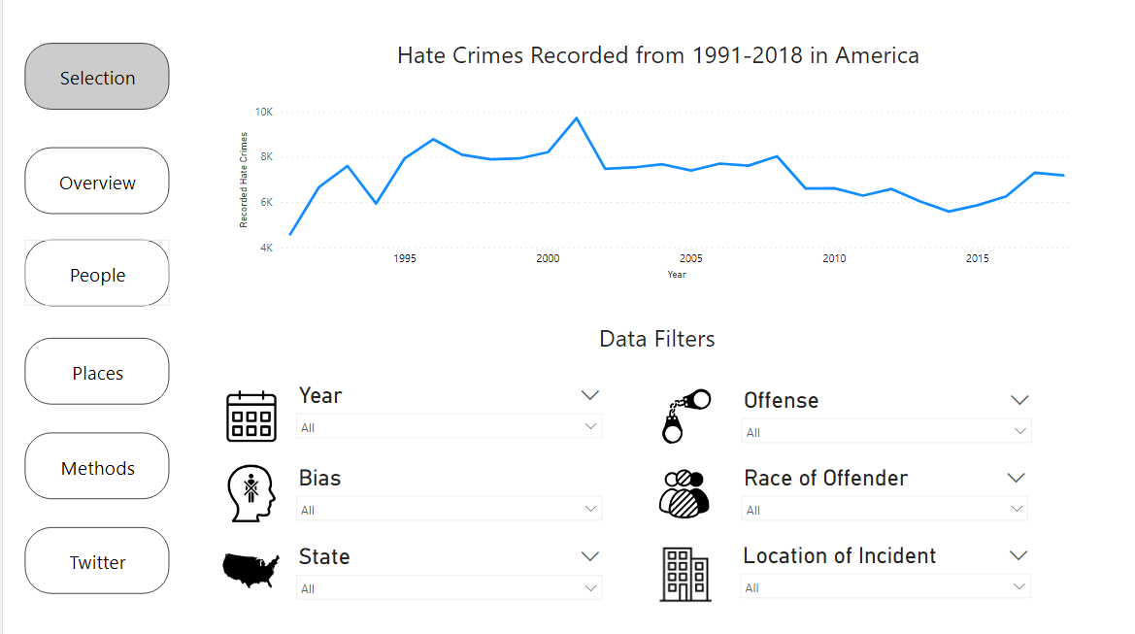

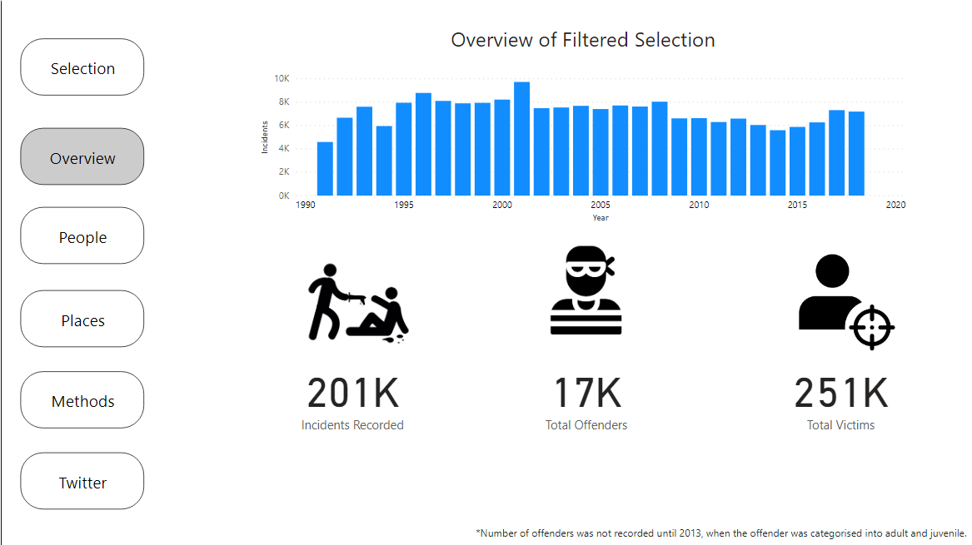

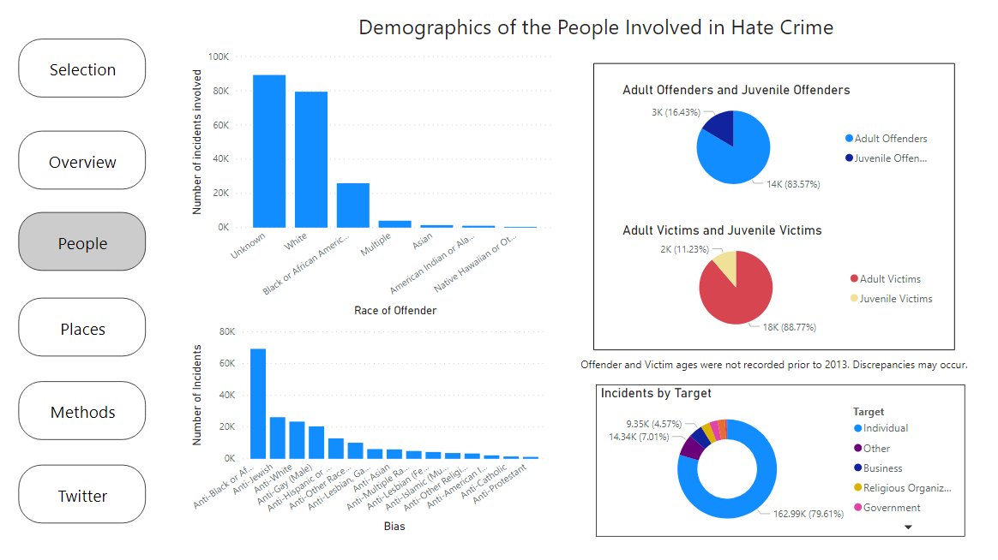

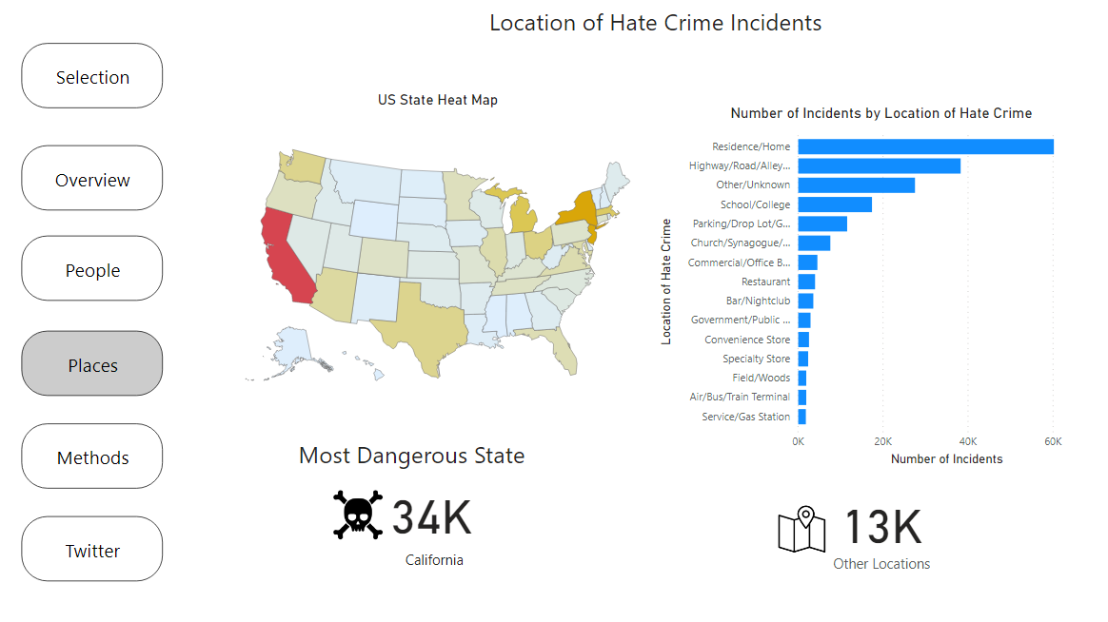

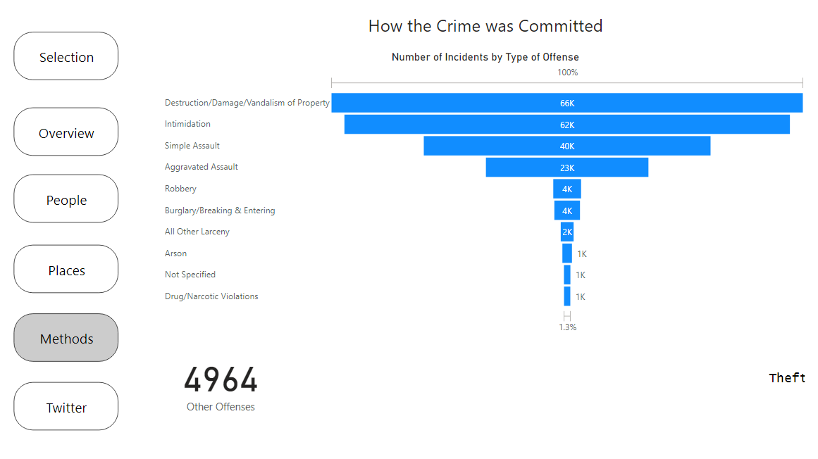

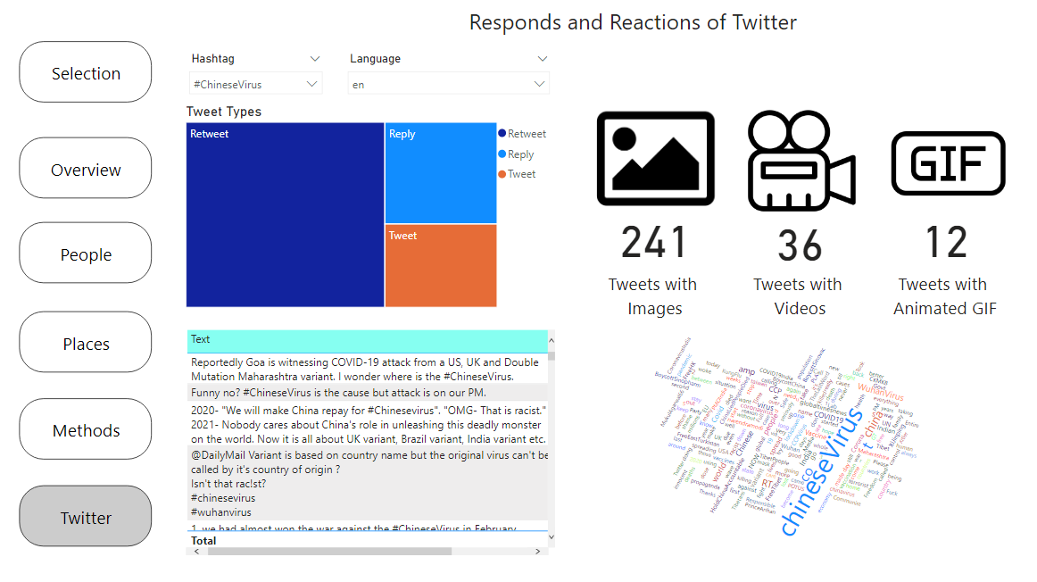

5. Other info
Using Microsoft Cognitive Services, an attempt was made to perform sentiment analysis on the tweets – determining if the tweet was positive or negative. This did not come to pass, as the API would only allow 1000 requests per minute, and with little to no knowledge on F# (the coding language), a solution could not be created.

